**IV. Libre Office**

1. **Create a power point presentation in Libre Office**

**Steps:**

1. **Open libre office Impress**
2. **Select the slide**
3. **Type the necessary contents**
4. **Select animation in Meuu**
   1. **Add animation to the content**
5. **Select slide show to view the slides**
6. **Save the file**

**Output**



1. **Create a chart in libre office calc**

**Steps:**

1. **Open libre office calc**
2. **Insert the subjects and pass percentage data into the cells**
3. **Select the data**
4. **Select insert 🡪 chart**
5. **Select the various options in the chart**
6. **Add a new sheet**
7. **Add the data**
8. **Select insert🡪 chart🡪 pie chart**
9. **Save the file**

**Output**

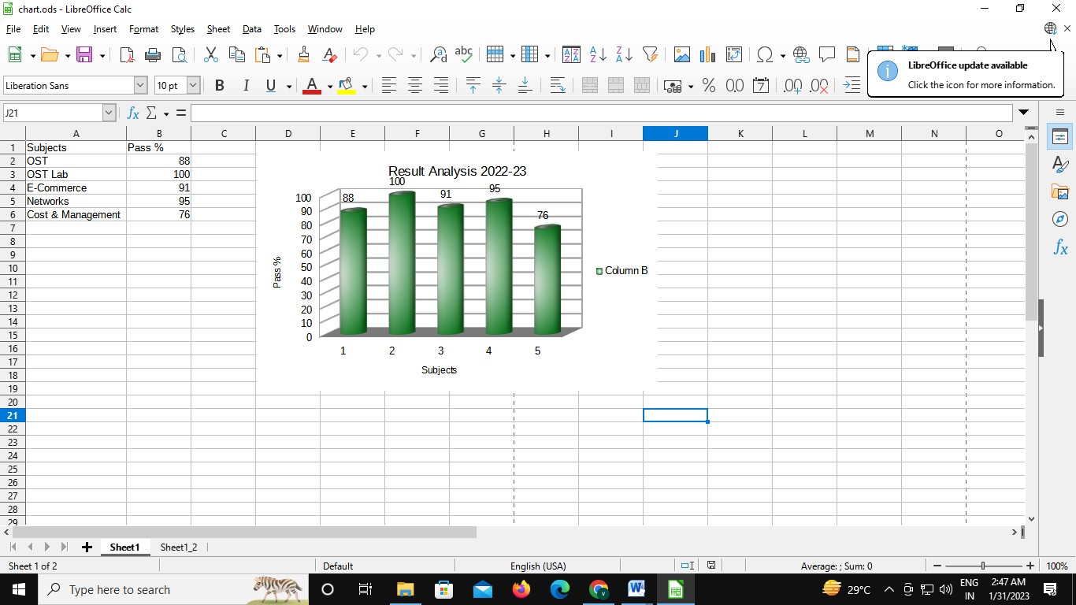

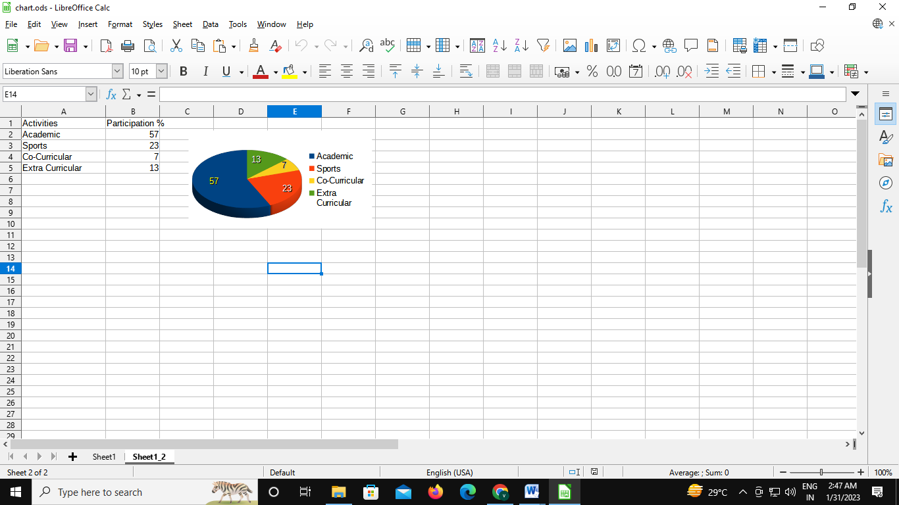

1. **Start LibreOffice Writer, create a new document and type some text in the document. Perform numbering styles in the document using LibreOffice Writer. Save the file**

**Steps:**

1. **Open libre office writer**
2. **Type the dat**
3. **Select insert** 🡪 **header and footer 🡪 add the header content and footer page no**
4. **Select bullets for sub titles**
5. **Insert the image using insert 🡪 image option**
6. **Save the file**

**Output**

